致：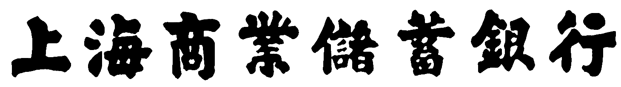 台鑒
TO：THE SHANGHAI COMMERCIAL & SAVINGS BANK, LTD.
Date 日期：

Application For Bill of lading(Air Waybill) Endorsement Issuance of Letter of Guarantee
提單(空運提單)背書申請書 擔保提貨申請書

茲附奉提單(空運提單)/擔保提貨書請 貴行惠予背書/簽署以便向船公司/空運公司請求提取下列貨物(請詳細
填寫船公司/空運公司名稱/地址)，
We enclose herewith for your endorsing/countersigning the bill of lading(air waybill)/our letter of guarantee
issued by/address to (name and address of shipping company/airline company),
該貨物係由起運地(place of departure)運抵目的地(place of destination)
for delivery of the following cargoes shipped from to
裝運於（船名-僅海運提單，name of vessel-If B/L only）
Per S.S.

L/C No. 信用狀號碼 | B/L(AWB) No. 提單號碼 | Amount 金額
Commodity貨名 | Quantity數量 | Shipping Marks嘜頭

貴行因背書 / 簽署上項提單(空運提單) / 擔保提貨書致引起之一切後果，包括提貨後之貨物瑕疵及貨物喪失，均由本申請人負責，絕不使 貴行因此而蒙受任何損失。茲同意倘嗣後寄達 貴行之單據與信用狀條款有任何不符時，本申請人願意無條件接受，並願意放棄抗辯權。另同意擔保提貨後提單寄達時，即將上項擔保提貨書換回送還 貴行註銷，或委由 貴行代勞在該項提單上背書逕交船公司（或其代理商）換回上項擔保提貨書，以便解除 貴行之保證責任。
In consideration of your endorsing / countersigning this bill of lading (air waybill)/ letter of guarantee, we hereby agree to hold you harmless for all consequences that may arise from your doing so including any loss of the goods to be received by us. We further agree that any discrepancies appearing on the original documents to be received by you later shall be acceptable to us in every respect without recourse to you and that on receipt of bill of lading for the above shipment, we will deliver the said letter of guarantee to you for cancellation or you may deliver the bill of lading direct to the shipping company ( or its agent) to release your letter of guarantee after endorsing on the bill of lading on our behalf.
倘若於申請提單背書 / 擔保提貨之同時，正本單據已寄達 貴行時，本申請人以此申請書作為同意接受進口單據之憑證，且該單據縱有瑕疵，本申請人亦願意接受，並授權 貴行轉知相關銀行解除一切擔保責任。
In case, at the time of this application, the original documents have been received by you, this application form shall serve as our acceptance of import documents and our approval to authorize you to release any guarantee held by
all relative banks for any discrepancies which may include therein.
申請人 Applicant
以下由本行填寫
□確認已完成貿融檢核表(完成時請於□打勾，並附上檢核表) |  |  | （請蓋原留印鑑之公司及負責人章）  ID：  TEL ：  聯絡人：
ED/LG No. |  |  | （請蓋原留印鑑之公司及負責人章）  ID：  TEL ：  聯絡人：
Date: |  |  | （請蓋原留印鑑之公司及負責人章）  ID：  TEL ：  聯絡人：
外匯專員(驗印) | 資深專員 | 外匯主管 | （請蓋原留印鑑之公司及負責人章）  ID：  TEL ：  聯絡人：

